**WEB**

**TECHNOLOGIES**

**LABORATORY**

**(LPCIT - 107)**

**PRACTICAL FILE**

**SUBMITTED TO:-**

**HANIT KAUR MA’AM**

**GNDEC, Ludhiana**

**SUBMITTED BY:-**

**Name:- DIVYANSHU KUMAR**

**URN/CRN:- 1905326/1921027**

**Class:- D2 IT**

**Section:- A2**

**INDEX**

P1. Create a simple web page by writing HTML using a simple text editor, Notepad. Demonstrate the following components of the web page: Page titles and Headings Paragraphs and Inline images

P2. Demonstrate the use of Links, Lists and Tables in HTML. You should be able to link separate pages and create named links within a document, using them to build a “table of contents”.

P3. Create simple Forms in HTML and demonstrate the use of various form elements like input box, text area, submit and radio buttons etc.

P4. Demonstrate the use of cascading style sheets (CSS) (inline, internal and external) to specify various aspects of style, such as colours and text fonts and sizes, in HTML document.

P5. Creation of Web pages using HTML5 and CSS3

P6. Demonstrate the use of Bootstrap Framework.

P7. Creating web pages using PHP.

**PRACTICAL - 1**

1. Create a simple web page by writing HTML using a simple text editor, Notepad. Demonstrate the following components of the web page: Page titles and Headings Paragraphs and Inline images

CODE:

<!DOCTYPE html>

<html>

<head>

    <title>"Everyday with NYFW"</title>

</head>

<body style="background-color:powderblue;">

    <img src="">

    <h3>“by Divyanshu | 1 day ago”</h3>

    <h1>“An Insider’s Guide to NYFW”</h1>

    <p>“NYFW can be both amazingly fun & incredibly overwhelming, especially if you’ve never been. Luckily, I’m here to

        give you an insider’s guide and make your first show a pleasurable experience. By taking my tips and tricks, and

        following your gut, you’ll have an unforgettable experience!”</p>

    <img src="https://bit.ly/3rYbFjK">

    <p>"If you’re lucky or connected you can get an invite, sans the price tag. But I wasn’t so lucky or connected my

        first 2 years so I’m here to help you out. First, plan out which shows are most important to you and make a

        schedule and this is a biggie: SET A BUDGET. If you’re worrying about blowing your cash the whole time you won’t

        have fun. Then check out prices, days, and times and prioritize the designers you want to see most. Lastly,

        purchase your tickets and get excited!”</p>

    <h2>“Getting Tickets & Picking the Shows”</h2>

    <h2>“Dressing for the Shows”</h2>

    <img src="https://bit.ly/3cXqVcI">

    <p>“Always be true to your own sense of style, if you don’t you’ll be uncomfortable the whole time and it will show.

        Remember, NYFW is about expressing yourself and taking in what the designers have chosen to express through

        their new lines. Also it’s important to wear shoes you’ll be comfortable in all day. Obviously you want to look

        good, but you’ll be on your feet all day long, so be prepared.”</p>

</body>

<p><strong>email:</strong> isa@fashionblog.com |<strong><br>phone:</strong> 917-555-1098<strong><br>address:</strong>

    371 284th St, New York, NY, 10001 </p>

</div>

</html>

Screenshot Of The Webpage:

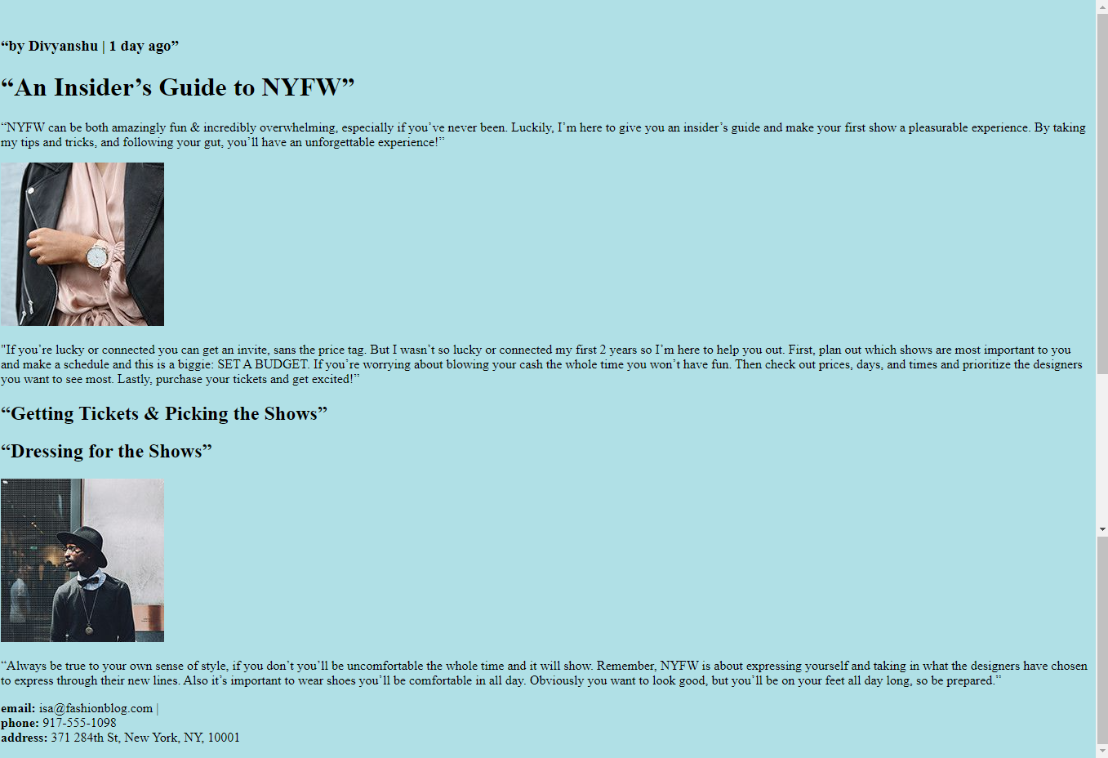

**PRACTICAL - 2**

1. Demonstrate the use of Links, Lists and Tables in HTML. You should be able to link separate pages and create named links within a document, using them to build a “table of contents”.

CODE:

<!DOCTYPE html>

<html>

<head>

  <title>Ship To It - Company Packing List</title>

  <link href="https://fonts.googleapis.com/css?">

<style>

body {

  background: powderblue;

  margin: 0;

  padding: 0;

}

ul {s

  padding: 0;

  margin: 0;

}

li {

  color: #FFF;

  display: inline-block;

  font-size: 16px;

  font-weight: 300;

  letter-spacing: 2px;

  margin: 0;

}

table {

  height: 40%;

  left: 10%;

  margin: 20px auto;

  position: static;

  width: 80%;

}

thead th {

  background: #88CCF1;

  color: #FFF;

  font-size: 16px;

  font-weight: 100;

  letter-spacing: 2px;

}

tr {

  background: #f4f7f8;

  border-bottom: 1px solid #FFF;

  margin-bottom: 5px;

}

</style>

</head>

<body>

<h1><a href="ork_Fashion_Week" target = "_blank"> IMPORT AND EXPORT SERVICES</a></h1>

<p>Import is a business term, which means purchase of both raw materials and finished products from another country. On the other hand, exports denotes sell of domestically produced goods and services to other countries.

These two aspects, Imports and exports, are vital factors in any country’s economy. As for the imports it helps a country to obtain goods and services it does not produce domestically while exports helps a country to earn foreign income which enables it to purchase imports.

The difference between nation’s exports and imports of goods and services determines its balance of trade. An economy is said to have a favorable balance of trade if its total exports exceed total imports. If its’ imports exceeds exports then it will be experiencing unfavorable balance of trade.</p>

  <table>

    <thead>

    <tr>

      <th>Company Name</th>

      <th>Number of Items to Ship</th>

      <th>Next Action</th>

    </tr>

    </thead>

    <tbody>

      <tr>

        <td>Adam's Greenworks</td>

        <td>14</td>

        <td>Package Items</td>

      </tr>

      <tr>

        <td>Davie's Burgers</td>

        <td>2</td>

        <td>Send Invoice</td>

      </tr>

      <tr>

        <td>Baker's Bike Shop</td>

        <td>3</td>

        <td>Send Invoice</td>

      </tr>

      <tr>

        <td>Miss Sally's Southern</td>

        <td>4</td>

        <td>Ship</td>

      </tr>

      <tr>

        <td>Summit Resort Rentals</td>

        <td>4</td>

        <td>Ship</td>

      </tr>

      <tr>

        <td>Strike Fitness</td>

        <td>1</td>

        <td>Enter Order</td>

      </tr>

    </tbody>

  </table>

</body>

</html>

Screenshot Of The Webpage:

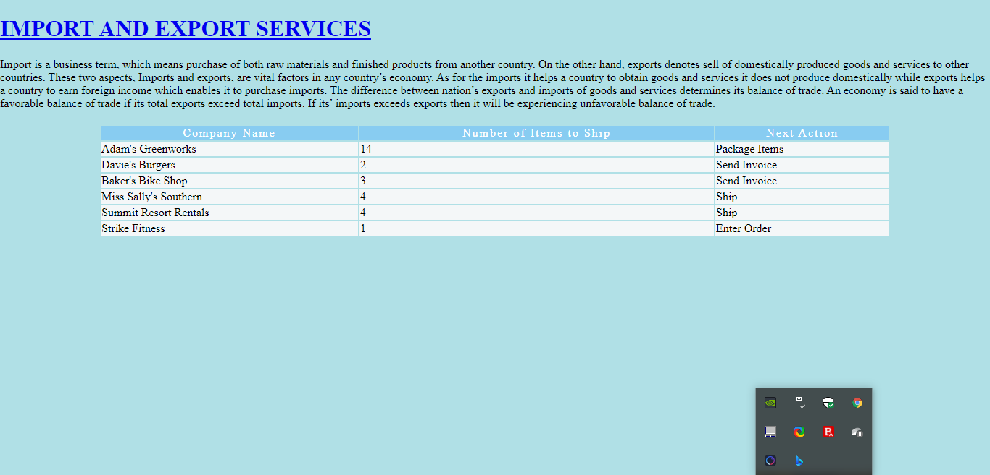

**PRACTICAL – 3**

1. Create simple Forms in HTML and demonstrate the use of various form elements like input box, text area, submit and radio buttons etc.

CODE:

<!DOCTYPE html>

<html lang="en" dir="ltr">

  <head>

    <meta charset="utf-8">

    <title>Forms Review</title>

  </head>

  <body>

    <section id="overlay">

      <img src="https://bit.ly/2QwlY22" alt="Davie's Burgers Logo" id="logo">

      <hr>

     <h1>Create a burger!</h1>

        <section class="protein">

          <label for="patty">What type of protein would you like?</label>

          <input type="text" name="patty" id="patty">

        </section>

        <hr>

        <section class="patties">

          <label for="amount">How many patties would you like?</label>

          <input type="number" name="amount" id="amount">

        </section>

        <hr>

        <section class="cooked">

          <label for="doneness">How do you want your patty cooked</label>

          <br>

          <span>Rare</span>

          <input type="range" name="doneness" id="doneness" value="3" min="1" max="5">

          <span>Well-Done</span>

        </section>

        <hr>

        <section class="toppings">

          <span>What toppings would you like?</span>

          <br>

          <input type="checkbox" name="topping" id="lettuce" value="lettuce">

          <label for="lettuce">Lettuce</label>

          <input type="checkbox" name="topping" id="tomato" value="tomato">

          <label for="tomato">Tomato</label>

          <input type="checkbox" name="topping" id="onion" value="onion">

          <label for="onion">Onion</label>

        </section>

        <hr>

        <section class="cheesy">

          <span>Would you like to add cheese?</span>

          <br>

          <input type="radio" name="cheese" id="yes" value="yes">

          <label for="yes">Yes</label>

          <input type="radio" name="cheese" id="no" value="yes">

          <label for="no">No</label>

        </section>

        <hr>

        <section class="bun-type">

          <label for="bun">What type of bun would you like?</label>

          <select name="bun" id="bun">

            <option value="sesame">Sesame</option>

            <option value="potatoe">Potato</option>

            <option value="pretzel">Pretzel</option>

          </select>

        </section>

        <hr>

        <section class="sauce-selection">

          <label for="sauce">What type of sauce would you like?</label>

          <input list="sauces" id="sauce" name="sauce">

          <datalist id="sauces">

            <option value="ketchup"></option>

            <option value="mayo"></option>

            <option value="mustard"></option>

          </datalist>

        </section>

        <hr>

        <section class="extra-info">

          <label for="extra">Anything else you want to add?</label>

          <br>

          <textarea id="extra" name="extra" rows="3" cols="40"></textarea>

        </section>

        <hr>

          <input type="submit" value="Submit">

        </section>

      </form>

    </section>

  </body>

</html>

Screenshot Of The Webpage:

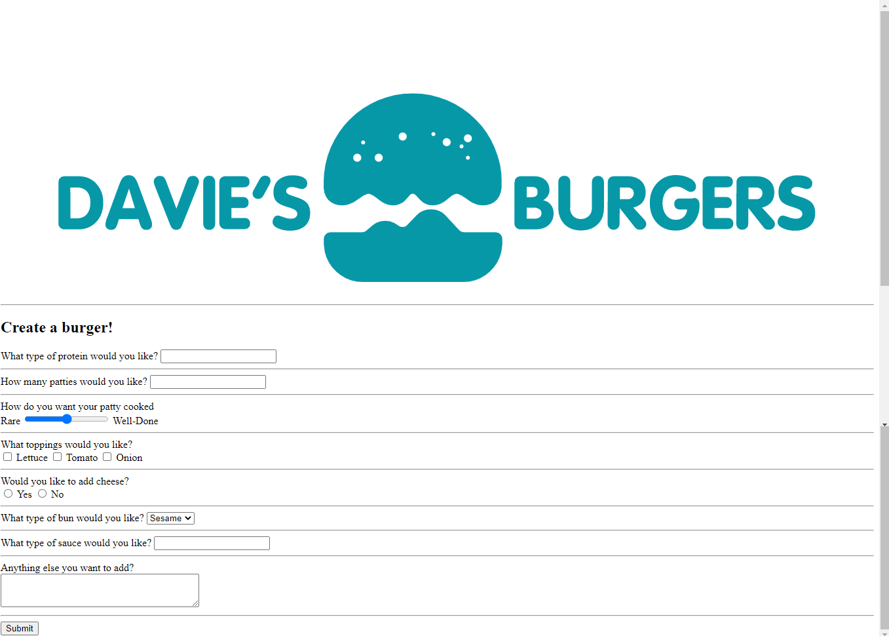

**PRACTICAL – 4**

1. Demonstrate the use of cascading style sheets (CSS) (inline, internal and external) to specify various aspects of style, such as colours and text fonts and sizes, in HTML document.

CODE:

<!DOCTYPE html>

<html>

<head>

    <title>The Best Coffee - By Region</title>

    <link href='https://fonts.googleapis.com/css?family=Covered+By+Your+Grace|Raleway:100,500,600,800' rel='stylesheet'>

    <style>

        body {

            padding: 0;

            margin: 0;

            background: #F7F7F7;

            /* Old browsers */

            background: -moz-linear-gradient(45deg, #F7F7F7 0%, #EAE0D5 100%);

            /* FF3.6-15 */

            background: -webkit-linear-gradient(45deg, #F7F7F7 0%, #EAE0D5 100%);

            /* Chrome10-25,Safari5.1-6 */

            background: linear-gradient(45deg, #F7F7F7 0%, #EAE0D5 100%);

        }

        /** Header styles **/

        .header {

            background-image: url(https://images.unsplash.com/photo-1455267847942-f4fdb784f0c5?dpr=1&auto=format&crop=entropy&fit=crop&w=1500&h=1000&q=80&cs=tinysrgb);

            height: 400px;

            background-position: center center;

        }

        .roasting {

            margin: 40px auto;

            padding: 20px 30px 40px 30px;

            background-color: #FFFFFF;

            overflow: auto;

            width: 75%;

            border-radius: 4px;

            align-self: center;

        }

        .roasting p {

            color: #938E89;

            text-align: center;

            line-height: 24px;

            font-family: 'Raleway', sans-serif;

            font-size: 16px;

            font-weight: 400;

        }

        .spectrum div {

            font: inherit;

            padding: 0 20px;

            color: #FFFFFF;

            overflow: auto;

            opacity: 0.9;

        }

        .spectrum p {

            color: #FFFFFF;

            text-align: left;

        }

        /* Roast types */

        .green {

            background-color: darkseagreen;

        }

        .vienna {

            background-color: brown;

        }

        /* Typography */

        h1 {

            color: #41292C;

            font-family: 'Covered By Your Grace', sans-serif;

            font-size: 100px;

            line-height: 76px;

            margin: 0;

            position: relative;

            text-align: center;

            top: 20%;

        }

        h2 {

            color: #E4BB97;

            font-family: 'Raleway', sans-serif;

            font-size: 28px;

            font-weight: 500;

            text-align: left;

            text-transform: uppercase;

        }

        h3 {

            color: #41292C;

            font-family: 'Raleway', sans-serif;

            font-size: 22px;

            font-weight: 500;

            text-align: center;

        }

        h4 {

            font-family: 'Raleway', sans-serif;

            font-size: 28px;

            font-weight: 700;

            line-height: .2em;

        }

        h5 {

            font-family: 'Raleway', sans-serif;

            font-size: 20px;

            line-height: .2em;

            font-weight: 300;

        }

        /* Page elements */

        ul {

            margin: 0 auto;

            padding: 0;

            width: 75%;

        }

        li {

            border-bottom: 1px solid #E4BB97;

            list-style: none;

            margin: 100px 0px;

            padding-bottom: 60px;

        }

        p {

            color: #444444;

            line-height: 32px;

            font-family: 'Raleway', sans-serif;

            font-size: 20px;

            font-weight: 100;

        }

        a {

            color: #214E34;

            font-family: 'Raleway', sans-serif;

            font-size: 13px;

            font-weight: 900;

            text-align: left;

            text-transform: uppercase;

            text-decoration: none;

            letter-spacing: 2px;

        }

    </style>

</head>

<body>

    <div class='header'>

        <h1>The Best Coffee Regions</h1>

    </div>

    <div class='roasting'>

        <h3>A Note on Roasting</h3>

        <p>Roasting coffee transforms the chemical and physical properties of raw coffee beans into roasted coffee

            products. This process is what produces the characteristic flavor of coffee by causing the green coffee

            beans to change in taste. Many coffee roasters determine the level of roast by eye, assessing the color of

            the beans to determine the desired roast-level.</p>

        <br>

        <div class='spectrum'>

            <div class='green'>

                <h4>Green Beans</h4>

                <h5>22&degC (72&degF)</h5>

                <p>Green coffee as it arrives at the dock. They can be stored for approximately 12-18 months in a

                    climate controlled environment before quality loss is noticeable.</p>

            </div>

            <div class='vienna'>

                <h4>Vienna Roast</h4>

                <h5>230&degC (446&degF)</h5>

                <p>Moderate dark brown with light surface oil, more bittersweet, caramel flavor, acidity muted. In the

                    middle of second crack. Any origin characteristics have become eclipsed by roast at this level.</p>

            </div>

        </div>

    </div>

    <ul>

        <li>

            <h2>Brazil</h2>

            <p>Arabica dominates both Brazil and the world as a whole with about 85% of the production; robusta accounts

                for the remaining 30%. In Brazil, arabica production is located in the main coffee-growing cluster of

                states led by Rio where arabica is

                produced almost exclusively. Robusta is primarily grown in the northwestern much smaller state of

                Espirito Santo where about 80% of the coffee is robusta.</p>

            <a href='#'>Learn More about Brazil</a>

        </li>

        <li>

            <h2>Colombia</h2>

            <p>Colombia has a reputation as producing mild, well balanced coffee beans.Colombia's average annual coffee

                production of 11.5 million bags is the third total highest in the world, after Brazil and Vietnam;

                though highest in terms of the arabica

                bean. The beans are exported to United States, Germany, France, Japan, and Italy. Most coffee is grown

                in the Colombian coffee growing axis region.</p>

            <a href='#'>Learn More about Colombia</a>

        </li>

        <li>

            <h2>India</h2>

            <p>Indian coffee, grown mostly in southern India under monsoon rainfall conditions, is also termed as

                'Indian monsooned coffee'. Its flavor is defined as: 'At its best similar to the flavor characteristics

                of Pacific coffees, but at its worst bland and uninspiring'. The two well known species of coffee grown

                are the Arabica and Robusta. Probably the most commonly planted Arabica in India and Southeast Asia is

                S.795.</p>

            <a href='#'>Learn More about India</a>

        </li>

    </ul>

</body>

</html>

Screenshot Of The Webpage:

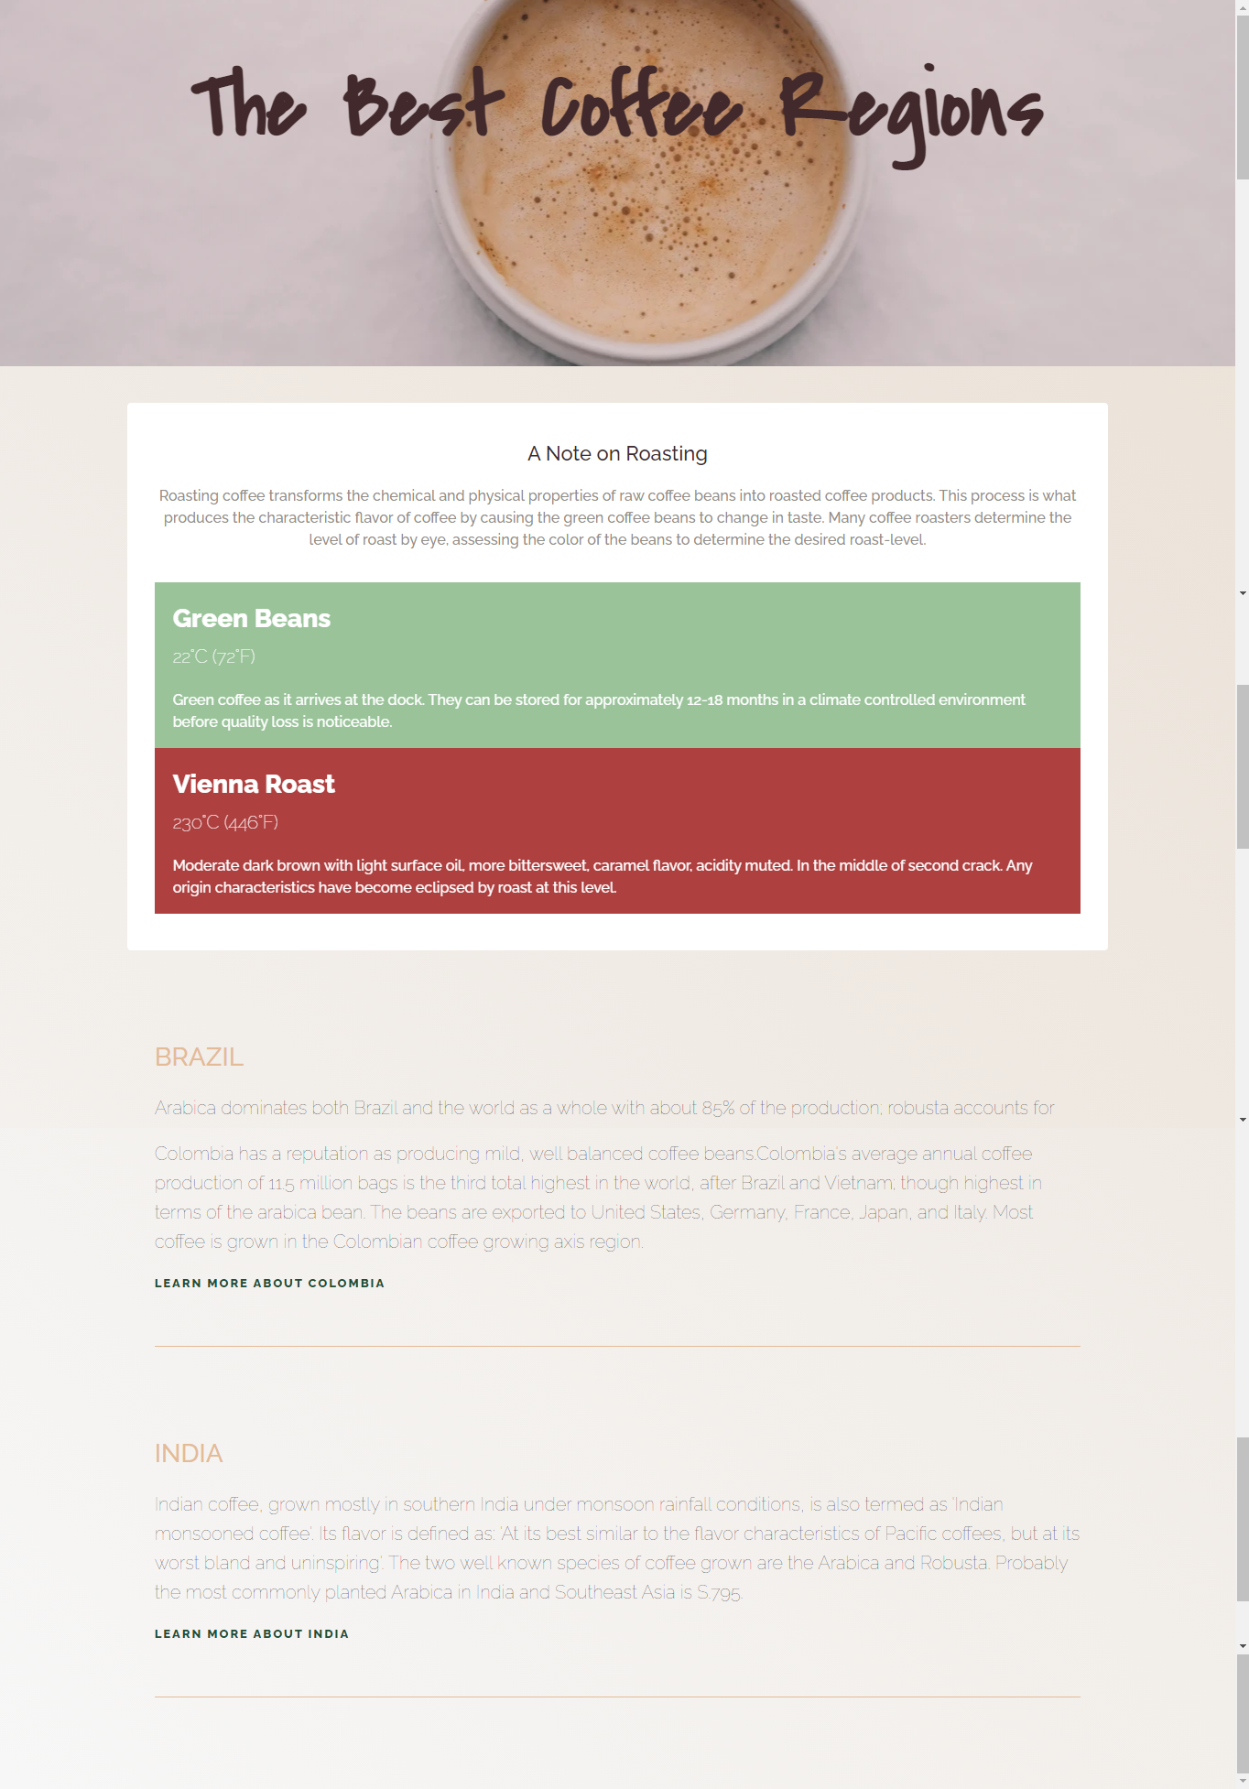

**PRACTICAL – 5**

1. Creation of Web pages using HTML5 and CSS3.

CODE:

<!DOCTYPE html>

<html>

<head>

  <title>Please Participate in Our Survey!</title>

</head>

<body>

   <style>

       body {

  background-color: #FFF;

  margin: 0 auto;

}

header {

  background-color: #466995;

  border-bottom: 1px solid #466995;

}

ul {

  margin: 30px auto;

  padding: 0 20px;

  text-align: center;

}

li {

  color: #FFF;

  font-family: 'Oswald', sans-serif;

  font-size: 16px;

  font-weight: 300;

  text-transform: uppercase;

}

li:hover {

  color: #DBE9EE;

}

h1 {

  color: #466995;

  font-family: 'Oswald', sans-serif;

  font-size: 32px;

  font-weight: 300;

  text-transform: uppercase;

}

h2 {

  color: #333;

  font-family: 'Varela Round', sans-serif;

  font-size: 26px;

  font-weight: 100;

  margin: 0 auto 20px auto;

}

h3 {

  color: #466995;

  font-family: 'Oswald', sans-serif;

  font-size: 18px;

  text-align: center;

  font-weight: 700;

  text-transform: uppercase;

  padding: 30px;

}

h4 {

  color: #466995;

  font-family: 'Oswald', sans-serif;

  font-size: 18px;

  font-weight: 300;

  letter-spacing: 2px;

  text-align: center;

  text-transform: uppercase

}

p {

  color: #333;

  font-family: 'Varela Round', sans-serif;

  font-size: 18px;

}

footer {

  background-color: #DBE9EE;

  text-align: center;

}

.welcome {

  background-color: #DBE9EE;

  box-sizing: border-box;

  padding: 40px;

  text-align: center;

  width: 100%;

}

.question {

  text-align: center;

}

.answer {

  border: 1px solid #466995;

  margin: 20px;

}

.answer:hover {

  background: #C0D6DF;

  color: #FFF;

}

   </style>

  <header>

    <ul>

      <li>Question 1</li>

      <li>Question 2</li>

      <li>Question 3</li>

      <li>Question 4</li>

      <li>Question 5</li>

      <li>Question 6</li>

    </ul>

  </header>

  <div class="welcome">

    <h1>Welcome to our survey!</h1>

    <p>We're looking forward to getting your answers so we can make sure our products and services are the best they can be!</p>

  </div>

  <div class="question">

    <h4>Question 1</h4>

    <h2>I like participating in physical activity such as running, swimming, or biking.</h2>

    <div class="answer">

      <h3>Disagree</h3>

    </div>

    <div class="answer">

      <h3>Neutral</h3>

    </div>

    <div class="answer">

      <h3>Agree</h3>

    </div>

  </div>

  <div class="question">

    <h4>Question 2</h4>

    <h2>I try to keep up to date with the latest fashion in active wear.</h2>

    <div class="answer">

      <h3>Disagree</h3>

    </div>

    <div class="answer">

      <h3>Neutral</h3>

    </div>

    <div class="answer">

      <h3>Agree</h3>

    </div>

  </div>

  <div class="question">

    <h4>Question 3</h4>

    <h2>I purchase clothing online regularly.</h2>

    <div class="answer">

      <h3>Disagree</h3>

    </div>

    <div class="answer">

      <h3>Neutral</h3>

    </div>

    <div class="answer">

      <h3>Agree</h3>

    </div>

  </div>

  <div class="question">

    <h4>Question 4</h4>

    <h2>I try to buy goods that are designed and/or manufactured in my home country.</h2>

    <div class="answer">

      <h3>Disagree</h3>

    </div>

    <div class="answer">

      <h3>Neutral</h3>

    </div>

    <div class="answer">

      <h3>Agree</h3>

    </div>

  </div>

  <div class="question">

    <h4>Question 5</h4>

    <h2>I look to famous athletes when trying to choose what to wear when training.</h2>

    <div class="answer">

      <h3>Disagree</h3>

    </div>

    <div class="answer">

      <h3>Neutral</h3>

    </div>

    <div class="answer">

      <h3>Agree</h3>

    </div>

  </div>

</body>

</html>

Screenshot Of The Webpage:

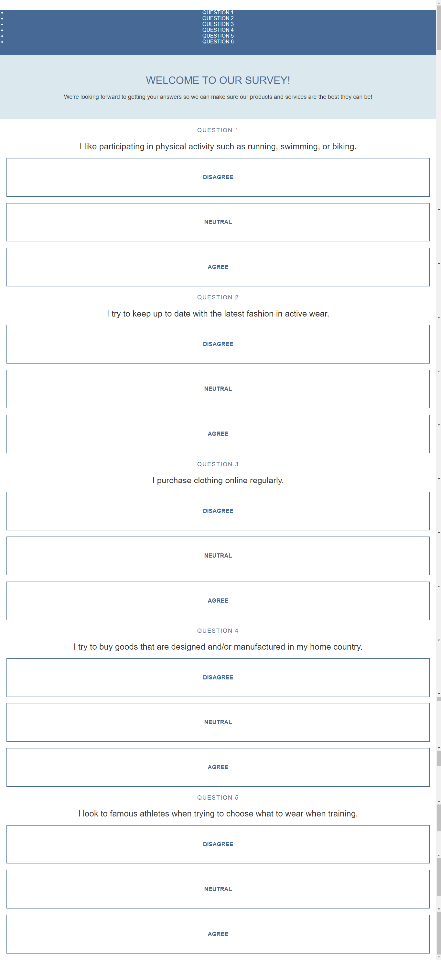

**PRACTICAL – 6**

1. Demonstrate the use of Bootstrap Framework.

CODE:

<!DOCTYPE html>

<html lang="en">

<head>

  <meta charset="UTF-8">

  <meta name="viewport" content="width=device-width, initial-scale=1.0">

  <meta http-equiv="X-UA-Compatible" content="ie=edge">

  <!-- Bootstrap CSS -->

  <link rel="stylesheet" href="https://stackpath.bootstrapcdn.com/bootstrap/4.2.1/css/bootstrap.min.css" integrity="sha384-GJzZqFGwb1QTTN6wy59ffF1BuGJpLSa9DkKMp0DgiMDm4iYMj70gZWKYbI706tWS" crossorigin="anonymous">

  <title>Adhoc</title>

</head>

<body>

  <!-- Navbar Component -->

  <nav class="navbar navbar-expand-lg navbar-light bg-light sticky-top">

    <a class="navbar-brand" href="#">

    <img src="https://s3.amazonaws.com/codecademy-content/courses/learn-bootstrap-4/adhoc/logo.png" alt="business logo">

    </a>

    <button class="navbar-toggler" type="button" data-toggle="collapse" data-target="#navbarSupportedContent" aria-controls="navbarSupportedContent" aria-expanded="false" aria-label="Toggle navigation">

      <span class="navbar-toggler-icon"></span>

    </button>

    <div class="collapse navbar-collapse" id="navbarSupportedContent">

      <ul class="navbar-nav mr-auto">

        <li class="nav-item active">

          <a class="nav-link" href="#">Home <span class="sr-only">(current)</span></a>

        </li>

        <li class="nav-item">

          <a class="nav-link" href="#">About Us</a>

        </li>

        <li class="nav-item">

          <a class="nav-link" href="#">Our Team</a>

        </li>

        <li class="nav-item">

          <a class="nav-link" href="#">Contact Us</a>

        </li>

      </ul>

    </div>

  </nav>

  <!-- Jumbotron -->

  <div class="jumbotron jumbotron-fluid" style="background:url(https://s3.amazonaws.com/codecademy-content/courses/learn-bootstrap-4/adhoc/jumbotron.png) no-repeat; background-size: cover;">

    <br>

    <br>

    <div class="bg-secondary text-center text-white my-5">

      <h1 class="display-4">Administration made easy</h1>

      <p class="lead text-center text-white">Adhoc is an on-demand administrative service for your company growth </p>

    </div>

      <br>

      <br>

  </div>

  <!-- Container -->

  <div class="container">

    <!-- Quote Section -->

    <div class="row">

      <div class="col">

        <h2 class="font-italic font-weight-light text-left">"Thanks to Adhoc we now have beautiful and faithful service every

          day. Our customers are happy and engagement has drastically increased. Highly recommend!"</h2>

        <p class="text-right font-weight-bold font-italic my-5">-Dave Ellavar, <span class="font-weight-light font-italic">Academy of Code</span></p>

      </div>

    </div>

    <hr>

    <!-- Why Adhoc? Text -->

    <div class="row">

      <div class="col">

        <h2 class="text-center display-4 mt-3 mb-5">Why Adhoc?</h2>

      </div>

    </div>

    <!-- Image Reasons Section -->

    <div class="row">

      <div class="col col-md-4 col-7 mx-auto">

        <!-- First card goes here -->

          <div class="card border-0">

          <img class="card-img-top" src="https://s3.amazonaws.com/codecademy-content/courses/learn-bootstrap-4/adhoc/experienced.png" alt="experienced icon">

          <div class="card-body">

            <p class="card-text text-center">Over 9000 happy clients, and we learn something new from each one.</p>

            </div>

          </div>

        </div>

      <div class="col col-md-4 col-7 mx-auto">

        <!-- Second card goes here -->

          <div class="card border-0">

          <img class="card-img-top" src="https://s3.amazonaws.com/codecademy-content/courses/learn-bootstrap-4/adhoc/fun.png" alt="fun icon">

          <div class="card-body">

            <p class="card-text text-center">Administration? Fun? Yea, somehow we make it happen.</p>

          </div>

        </div>

     </div>

      <div class="col col-md-4 col-7 mx-auto">

        <!-- Third card goes here -->

          <div class="card border-0">

          <img class="card-img-top" src="https://s3.amazonaws.com/codecademy-content/courses/learn-bootstrap-4/adhoc/smart.png" alt="smart icon">

          <div class="card-body">

            <p class="card-text text-center">Innovative solutions to the trickest of everyday tasks.</p>

          </div>

      </div>

     </div>

    </div>

    <!-- Meet the Team Section -->

    <div class="row rounded-top bg-dark">

      <div class="col-m-6 mb-5 mx-auto">

        <h2 class="text-white text-center bg-dark display-4 my-3">Meet the Team</h2>

      </div>

    </div>

    <!-- Team Pictures Carousel -->

    <div class="row bg-dark rounded-bottom">

      <div class="col-m-6 mb-5 mx-auto">

        <!-- Carousel Component -->

        <div id="staffCarousel" class="carousel slide" data-ride="carousel">

          <div class="carousel-inner">

            <div class="carousel-item active">

              <img src="https://s3.amazonaws.com/codecademy-content/courses/learn-bootstrap-4/adhoc/amie.png" class="d-block mx-auto" style="width: 400px;" alt="Arnie S. CTO">

              <div class="carousel-caption d-block bg-dark py-0 rounded-pill">

                <p class='text-center font-weight-bold my-0'>CTO: <span class='font-weight-light'>Amie S.</span></p>

              </div>

            </div>

            <div class="carousel-item">

              <img src="https://s3.amazonaws.com/codecademy-content/courses/learn-bootstrap-4/adhoc/brian.png" class="d-block mx-auto" style="width: 400px;" alt="picture of Brian M. the CEO.">

              <div class="carousel-caption d-block bg-dark py-0 rounded-pill">

                <p class='text-center font-weight-bold my-0'>CEO: <span class='font-weight-light'>Brian M.</span></p>

              </div>

            </div>

            <div class="carousel-item">

              <img src="https://s3.amazonaws.com/codecademy-content/courses/learn-bootstrap-4/adhoc/andy.png" class="d-block mx-auto" style="width: 400px;" alt="picture of Andy C. the CFO.">

              <div class="carousel-caption d-block bg-dark py-0 rounded-pill">

                <p class='text-center font-weight-bold my-0'>CFO: <span class='font-weight-light'>Andy C.</span></p>

             </div>

            </div>

            <div class="carousel-item">

              <img src="https://s3.amazonaws.com/codecademy-content/courses/learn-bootstrap-4/adhoc/angela.png" class="d-block mx-auto" style="width: 400px;" alt="picture of Angela W. the COO.">

              <div class="carousel-caption d-block bg-dark py-0 rounded-pill">

                <p class='text-center font-weight-bold my-0'>COO: <span class='font-weight-light'>Angela W.</span></p>

              </div>

            </div>

          </div>

          <a class="carousel-control-prev" href="#staffCarousel" role="button" data-slide="prev">

            <span class="carousel-control-prev-icon" aria-hidden="true"></span>

            <span class="sr-only">Previous</span>

          </a>

          <a class="carousel-control-next" href="#staffCarousel" role="button" data-slide="next">

            <span class="carousel-control-next-icon" aria-hidden="true"></span>

            <span class="sr-only">Next</span>

          </a>

        </div>

      </div>

    </div>

  </div>

  <!-- Footer -->

  <footer class="text-center">2019 Adhoc &copy;

  </footer>

  <!-- Bootstrap's JavaScript Files -->

  <script src="https://code.jquery.com/jquery-3.3.1.slim.min.js" integrity="sha384-q8i/X+965DzO0rT7abK41JStQIAqVgRVzpbzo5smXKp4YfRvH+8abtTE1Pi6jizo" crossorigin="anonymous"></script>

  <script src="https://cdnjs.cloudflare.com/ajax/libs/popper.js/1.14.6/umd/popper.min.js" integrity="sha384-wHAiFfRlMFy6i5SRaxvfOCifBUQy1xHdJ/yoi7FRNXMRBu5WHdZYu1hA6ZOblgut" crossorigin="anonymous"></script>

  <script src="https://stackpath.bootstrapcdn.com/bootstrap/4.2.1/js/bootstrap.min.js" integrity="sha384-B0UglyR+jN6CkvvICOB2joaf5I4l3gm9GU6Hc1og6Ls7i6U/mkkaduKaBhlAXv9k" crossorigin="anonymous"></script>

</body>

</html>

Screenshot Of The Webpage:

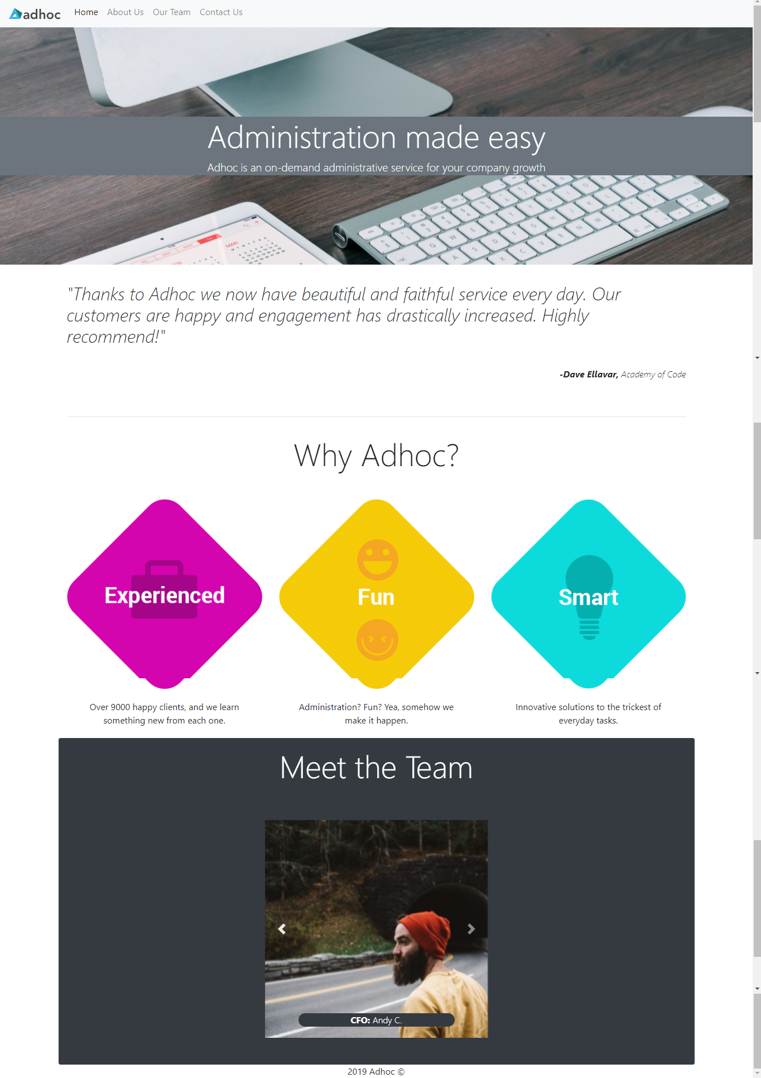

7. Creating web pages using PHP.

CODE:

<?php

$name = "";

$character = "";

$email = "";

$birth_year = 1969;

$validation_error = "";

$existing_users = ["admin", "guest"];

if ($_SERVER["REQUEST_METHOD"] == "POST") {

    $raw_name = trim(htmlspecialchars($_POST["name"]));

    if (in_array($raw_name, $existing_users)) {

        $validation_error .= "This name is taken. <br>";

    } else {

        $name = $raw_name;

    }

    $raw_character = $_POST["character"];

    if (in_array($raw_character, ["wizard", "mage", "orc"])) {

        $character = $raw_character;

    } else {

        $validation_error .= "You must pick a wizard, mage, or orc. <br>";

    }

    $raw_email = $_POST["email"];

    if (filter_var($raw_email, FILTER_VALIDATE_EMAIL)) {

        $email = $raw_email;

    } else {

        $validation_error .= "Invalid email. <br>";

    }

    $raw_birth_year = $_POST["birth_year"];

    $options = ["options" => ["min_range" => 1900, "max_range" => date("Y")]];

    if (filter_var($raw_birth_year, FILTER_VALIDATE_INT, $options)) {

        $birth_year = $raw_birth_year;

    } else {

        $validation_error .= "That can't be your birth year. <br>";

    }

}

?>

<h1>Create your profile</h1>

<form method="post" action="">

    <p>

        Select a name: <input type="text" name="name" value="<?php echo $name; ?>">

    </p>

    <p>

        Select a character:

        <input type="radio" name="character" value="wizard" <?php echo ($character == 'wizard') ? 'checked' : '' ?>> Wizard

        <input type="radio" name="character" value="mage" <?php echo ($character == 'mage') ? 'checked' : '' ?>> Mage

        <input type="radio" name="character" value="orc" <?php echo ($character == 'orc') ? 'checked' : '' ?>> Orc

    </p>

    <p>

        Enter an email:

        <input type="text" name="email" value="<?php echo $email; ?>">

    </p>

    <p>

        Enter your birth year:

        <input type="text" name="birth_year" value="<?php echo $birth_year; ?>">

    </p>

    <p>

        <span style="color:red;"><?= $validation_error; ?></span>

    </p>

    <input type="submit" value="Submit">

</form>

<h2>Preview:</h2>

<p>

    Name: <?= $name; ?>

</p>

<p>

    Character Type: <?= $character; ?>

</p>

<p>

    Email: <?= $email; ?>

</p>

<p>

    Age: <?= date("Y") - $birth_year; ?>

</p>

Screenshot Of The Webpage:

